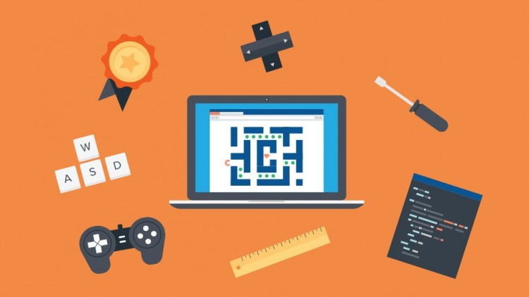

Final Report

unity 2d game

Darragh Lally | g00220290 | 2020

# Post Development Report

The following is a short report to be submitted with my game solution. Its intention is to describe some of the aspects of the development of the game describing the design choices I made, struggles I encountered and recommendations for future development.

Although we got a some-what early start to the project I have found our current circumstances, that is the Covid19 pandemic, have hindered my progress. I believe I had set out achievable objectives in my Game Design Document but ultimately learned I had bitten off more than I could chew… Even if I still had access to the college and its resources.

I had intended to make an Endless Runner style game where the user had no control over the movement of the player on the x-axis… I had to scrap that an incorporate a different control set up. The user now has control of movement on the x-axis in both a positive and negative direction. I have added jump to the players avatar. I started by having jump command bind to the space key, this became awkward when implementing the shooting mechanic. There was no suitable key to bind shoot to if I continued the bind between jump and space. I moved jump to the W key as positive y-axis movement is restricted to jumping this worked out well. Now the key layout stands at the standard WASD Space. Jump turned out to be more difficult than I had thought. I am using a physics system, so the user’s avatar experiences gravity. Playing around with mass and velocity settings I got to a point that I am ok with. I could not figure out how to prevent the player from ‘multi’ jumping. This is something I need to work on going forward.

I had no problem getting my first spawn point working, but for my game I wanted at least two points. My attempts at adding further spawn points failed. I tried multiple fixes but each lead to new issues! It will be noticed that there is an error notification when running the source code, this error is related to the spawn points… the engine is expecting multiple points but only has one. It is not a critical error and the game will still run.

# Conclusion

I am disappointed with my submission. Although I’m handing up an unfinished product, I have still learnt many lessons along the way. I list some of those lessons below,

* *Time Management* – I did not account for the volume of work involved this semester. It was a serious misjudgment on my behalf. I should have put more consideration into this, it would have meant a finer finish even if still not a fully finished application. I have begun a written diary in Bullet Journal form to help me manage my time better and help me focus on individual tasks.
* *Unity* – My understanding of Unity as a development platform and C# language has been expanded on. Working with Git and Unity is new to me, I got to meddle with the Desktop version of Git. It was the most efficient way of adding my project to some form of repository. I will use this Desktop application in the future when adding projects of this type to my GitHub account.
* *Game Development* – This is my first project aimed at developing a game. Going into it I knew it was not something I wanted to pursue as a career choice but as something I could explore in any spare time I might find. I am conscious that this mind set contributed to my mismanagement of time. I have learned that no matter task at hand I must commit myself to it.
* *Unforeseen Circumstances* – Something, by nature and definition, that we can not account for. The current Covid-19 emergency has impacted my schedule in an extreme way, as I am sure many of my peers both educator and educatee alike. While this project began before this current crisis it has impacted my performance across the board. I hope I am now more prepared for other such circumstances.